**Dynamic Convolutional Neural Networks for Sentiment Analysis**

**Background:**

Machine learning, which is a subset of artificial intelligence, is one of the most published and researched fields in computer science. Machine learning first came about in 1950 when Alan Turing proposed the Turing Test, a test to determine whether a computer was truly “intelligent” or not. If a computer can fool a human into thinking that the computer is a human, then the computer passed the Turing Test.

Since Alan Turing proposed the Turing Test, machine learning has thrived and advanced in ways that he never imaged. The first computer program to be considered a machine-learning algorithm was introduced in 1952 by Arthur Samuel. This simple program took note of the most crucial moves during games of checkers it played and in subsequent games tried to use those moves. Next large leap in machine learning was the invention of the perceptron by Frank Rosenblatt in 1957. The perceptron was a simplified mathematical model of a neuron in a brain. Perceptrons evolved into the nodes of neural networks. However, even though the nodes of neural networks resemble the neurons found inside of brains, neural networks are not trying to mechanistically imitate the processes of the brain.

Between 1960 and 1990 the field of machine learning developed many important algorithms. However, the most important change that happened in this time was the shift from knowledge-based approaches to data-driven approaches. Computer scientists discovered that computers perform best when they try to mathematically optimize a model instead of picking out the most influential behavior as had been done with Samuel’s algorithm in the 50s. This meant that now most machine-learning algorithms converted a problem into numerical form, usually a vector or matrix-based representation, and tried to minimize an equation given this input vector and the “answer” to the vector. This minimization is done by “training” the algorithm on many example problems and their solutions. For example, a machine learning checkers algorithm may be given 500 million examples of checkers games, all of which are represented as vectors. It would then try to minimize some function by adjusting parameters. Each time it gets a move wrong in the checkers games it is simulating, one of the parameters is pushed slightly in one direction to attempt to reduce the amount of errors.

Ever since this realization the field of machine learning has blossomed. There have been many astounding feats of machine learning that have occurred just within the past year. The machine learning algorithm AlphaGo beat a human master of Go, which is considered the hardest game for a computer to play due to the seemingly human intuition needed to make good moves. Moreover, image classification algorithms have achieved error rates of less than 7% (for perspective, humans who have “trained” themselves for a week on the same task had an error rate of about 5%). As well, machine-learning algorithms have far surpassed us in games such as chess and even Jeopardy.

Up until the 21st century no individual or company had the computational power to effectively train a neural network. However, a breakthrough in 2011 changed this. Google Brain developed an image classification program with accuracy unheard of using the previous machine learning techniques. This breakthrough opened the floodgates for the development of neural networks. Since then neural networks have only become more and more researched. Now there are many competitions each year held for computers to do tasks like image classification and speech synthesis. Companies and institutions have released code to allow an individual to easily develop and research neural networks. The most recent of these releases is called TensorFlow. Developed by Google and released in the fall of 2015, TensorFlow is a complex and efficient framework for developing neural networks. TensorFlow allows a neural network to be trained and run on nearly anything, from a phone to a supercomputer.

There are many similarities between a neural network and the brain. Nonetheless, the two are quite different.

First, what does a biological neuron do? A biological neuron takes inputs from other neurons in the form of an electrical charge. The charges from each of the inputs are combined in the nucleus of the neuron and then, only if the charge in the nucleus reaches a certain threshold, the neuron will release some electricity itself. That neuron will act as an input to many other neurons. This large network of neurons is what forms the brain.

Artificial neural networks are much similar. They take inputs in the form of numbers, usually between 0 and 1. They sum up all of their inputs and evaluate them on an activation function. The biological neural network’s activation function called a stepper function. It can be easily defined as:

a(x) = 1 if x > t

0 otherwise

Where t is the threshold needed to activate the function. There are a number of problems with this activation function for artificial neural networks, including their simplicity and the function’s inability to be fully differentiated. This is why a different class of activation functions is often used. These are called sigmoid functions. They all resemble a stretched out S shape. The most common sigmoid function used in artificial neurons is the hyperbolic tangent function.

Now each of the neurons is connected to make an artificial neural network (ANN). First there is an input layer of nodes. These nodes are fed the values that represent the problem. For example, if the neural network were classifying 28 pixel by 28 pixel gray scale handwritten digits then the input layer would be composed of 784 numbers from 0-1 representing the 784 pixels of the image and the normalized value of that pixel. These nodes do not perform any activation functions, they simply output whatever their input is. Next each input node leads into each artificial neuron in the hidden layer. In the most basic ANN there is only 1 layer of neurons. The number of neurons in this hidden layer is often determined by a lot of guess and check work. The amount of neurons varies greatly between tasks. The tuning of this parameter along with a number of other parameters involved in training and testing a neural network is often the most time consuming step in building, training, and testing a neural network. As well, each of the connects between the input layer and the hidden layer have a weight associated with it. These weights are what are adjusted and changed. The weight acts as a multiplier for the “importance” of the input. For example, if a connection’s weight is 0.5 and its input is 0.9 then the neuron would get an input of 0.9 x 0.5 = 0.45.

Finally each neuron in the hidden layer is connected to every neuron in the output layer. Again these connections have weights associated with them. Once the output layer has evaluated the activation function on their input, they output the answer in numerical form.

The final step in constructing a neural network is the “training.” Through linear algebra the weights connecting neurons are gradually changed to try to find the minimum value of a function. This process is the heart of neural networks, but is also by far the most in-depth. First, it can take as many as 500 million examples for a neural network to be fully trained. Second, there are many ways to measure how far off from the answer the neural network currently is and many ways to choose which and by how much to adjust weights. As well, a neural network could be “trapped” in a local minimum, not the global minimum. Although a process called dropout can often combat this problem, there are still many other things that can go wrong in training neural networks.

Once the neural network is trained, it can finally be used to perform its intended task. There are many varieties of neural networks that thrive at many different tasks. The simplest neural network is a deep neural network. These neural networks have more than one layer of nodes in them (not counting the output layer). Another very common model is the convolutional neural network (CNN). CNNs focus on the pre-processing of data by repetitively abstracting it into more and more basic forms until they are left with the data in a highly abstract form. This data is then fed into a regular neural network. This pre-processing of the data can make the regular neural network much more effective in its task. A more recent variant of the CNN is called the dynamic-k max pooling convolutional neural network (DCNN). The main difference between a regular CNN and a DCNN is that a DCNN is able to adapt to the size of the input. There are also recurrent neural networks (RNNs), which use a specialized type of node that has “memory.” This “memory” of what was fed into it recently and what order this information was in allows for RNNs to thrive at tasks that require knowledge of context. Finally, there are a number of successful machine learning models that aren’t neural networks. The most popular non-neural network machine-learning model is the support vector machine (SVM). The SVM tries to find a line that best separates two categories of points. However, because data points are often in many more than two dimensions, an SVM is trying to find a many-dimensional plane (known as a hyper plane) that best separates the two categories of points. The SVM was the dominant model before 2011 and does decently at a variety of tasks, especially classification tasks.

**Research Question:**

How effective are dynamic-k max pooling convolutional neural networks (DCNNs) at different types of natural language processing tasks, including classification, contextual, and non-contextual tasks, as compared to other machine learning architecture (traditional convolutional neural networks and support vector machines)?

**Hypothesis:**

The dynamic-k max pooling convolutional neural network will perform slightly better than the convolutional neural network. The support vector machine will preform the worst.

**Abstract:**

Despite quickly showing their effectiveness in image processing, convolutional neural networks’ (CNNs) power has yet to be fully exposed in natural language processing (NLP) tasks. Although convolution layers are an very effective abstraction tool, it is believed that one of the main bottlenecks when CNNs work with text is the down sampling done by the max pooling layers. One model that has proven to effectively combat this down sampling is the dynamic-k max pooling convolutional neural network (DCNN), which is able to change the size of the pooling layer based on the size of input sentence. I investigated this model further writing and training a DCNN in TensorFlow and Python using short sentences from a dataset of movie and product reviews. As well, as a control wrote a CNN and a support vector machine (SVM), which is a lightweight yet effective primarily mathematical model for classifying words in space. I found that the SVM did surprisingly well with 72.0% accuracy, while the CNN performed with only 71.91% accuracy. The DCNN performed at 85.0%accuracy. These results are clearly indicative of the DCNN’s power in natural language processing tasks.

**Methods:**

* I looked on University of California Irvine. I found 2 data sets – a data set of Rotten Tomatoes movie reviews, and a data set of IMDB movie reviews.
* Wrote a basic convolutional neural network (CNN) and a dynamic-k max pooling convolutional neural network (DCNN) in Python 3.5 using TensorFlow 0.110rc0.
* The convolutional neural network contained an embedding layer. After this, I had filter layers. Each filter layer consisted of a convolution layer, a max pooling layer, and a rectified linear layer. I had 3 filters of size 3, 4, and 5. For each filter I had 128 * filter_size filter layers. Next, I had a dropout layer. For the output layer, I used a softmax to provide probabilities.
* The only difference between the CNN and the DCNN was that the size of the pooling layer in the DCNN depended on the size of the input sentence, while the size of the pooling layer was static in the CNN.
* Next I wrote a support vector machine. I used scikit-learn 0.18’s Support Vector Classifier (sklearn.svm.SVC). I preprocessed the text using a count vectorizer and tf-idf.
* Finally, I trained all 3 of the architectures using the Rotten Tomatoes movie review corpus for training data and the IMDB movie reviews corpus for testing.
* I used TensorFlow’s checkpoint feature as well as TensorBoard to generate graphs for loss as well as the visualization of the architectures.
* I used TensorFlow’s checkpoint feature as well as TensorBoard to generate graphs for loss as well as the visualization of the architectures.

**Results:**

After training and tuning all three models, I found that the DCNN performed the best. The CNN had an accuracy of 72.0% (Table 1). The dynamic-k max pooling convolutional neural network performed 13% better with an accuracy of 85.0% (Table 1). As well, the loss and accuracy curves for the training of both the CNN and the DCNN indicate a generally stable training (Figure 1 and Figure 2). The training for both the CNN and the DCNN took about 2 hours on a training of 200 epochs without GPU acceleration. The support vector machine performed with 72% accuracy (Table 1). As well, it had a precision of 89% and recall of 20% of negative test data and a precision of 55% and recall of 97% on positive test data (Table 2). Due to pipelining issues, I was unable to get the precision and recall values (which are represent how many false positives and “true negatives” the neural networks predicted) for the CNN or the DCNN.

|  |  |
| --- | --- |
|  | Accuracy |
| DCNN | 85.00% |
| CNN | 71.92% |
| SVM | 72.00% |

**Table 1.** The accuracy of the DCNN, CNN, and SVM architectures. These were calculated using my code, which was written in Python and primarily used TensorFlow and scikit learn.

|  |  |  |  |
| --- | --- | --- | --- |
|  | Precision | Recall | F1-Score |
| Negative | 98% | 20% | 33% |
| Positive | 55% | 97% | 70% |
| Average/Total | 72% | 59% | 52% |

**Table 2.** The precision, recall, and F1-Score of the SVM. This SVM was trained using scikit learn’s SVC class.

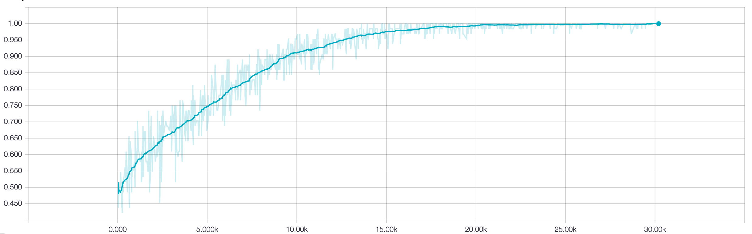

**Figure 1.** The accuracy of a training run of the DCNN. This accuracy appears exceptionally high due to the fact that it was calculated on the training data, not testing data. This run was 250 epochs long with a batch size of 64. The y axis is accuracy and the x axis is training steps. The graph was generated using TensorFlow’s check pointing feature along with TensorBoard. The graph is smoothed 60% using exponential smoothing.

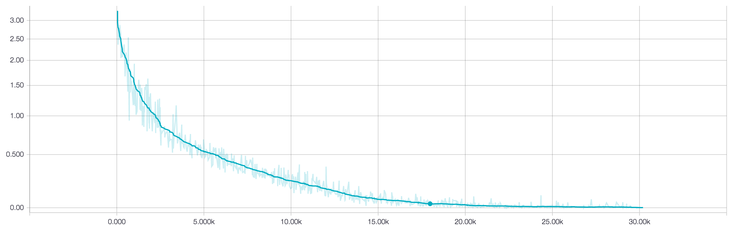

**Figure 2.** The loss of a training run of the DCNN. This run was 250 epochs long with a batch size of 64. The y axis is loss (calculated using softmax cross entropy) and the x axis is training steps. The graph was generated using TensorFlow’s check pointing feature along with TensorBoard. The graph is smoothed 60% using exponential smoothing.

**Discussion**:

My results were generally consistent with my hypothesis. However, the support vector machine actually did slightly better than the convolutional neural network. I believe that this can likely be attributed to the fact I preprocessed the data for the SVM using a count vectorizer and tf-idf. I believe that these two preprocessing steps helped the SVM greatly by removing a lot of noise from the data. Conversely, the lack of data and preprocessing meant that the CNN performed slightly lower than expected. The lack of data combined with the lack of preprocessing meant that not only did the CNN have to learn to ignore noise, but it only a short period of time to do it. On top of this, the CNN didn’t use L2-norm pooling, which meant it was even harder for the CNN to filter out noise. All of these factors combined meant that the CNN performed about 6% lower than expected3.

Even if the CNN had performed at 76% accuracy, the dynamic-k max pooling convolutional neural network would have still performed better. As shown in the original paper, the DCNN’s main strong point is the fact that it can adjust to different size inputs. The max pooling layer typically down samples the data after the convolution layer in order to help prevent over fitting and to help speed up the training of the neural network. However, it down samples both long and short sentences the same amount. This results in long sentences often being down sampled too much, meaning some data is lost, while short sentences are often down sampled too little, meaning that the network is still left with some noise. This may be helpful for images, but it is very helpful for sentences, which range from 10 to 100 words3. This size awareness is a large contributing factor in the DCNN’s success in natural language processing tasks.

**Conclusion:**

Despite the DCNN’s success with sentiment analysis due to its ability to adjust to the size of the input sentence, the DCNN still needs to be investigated further in order to prove its superiority over CNNs in other NLP tasks. One major thing that the DCNN lacks in temporal awareness. The DCNN doesn’t care what order the words in a sentence are arranged in. Although this generally doesn’t matter for sentiment analysis, for tasks such as machine translation and question answering this is very important. This is the main reason that the recurrent neural network remains as the champion in these sorts of tasks. This raises the question of whether the DCNN would be able to compete with the RNN in these sorts of tasks, and whether it is possible to blend the 2 models without “overabstracting” data.

As well, my models weren’t fully perfected. For example, I didn’t have time to tune the hyperparameters of all three models fully. If they were tuned, this would likely mean slightly better performance for all 3 models. Furthermore, both the DCNN and the CNN lack L2-norm pooling, which could increase both of their accuracies. Finally, some data preprocessing, primarily using a better encoder for sentences, would help improve the accuracy of both the CNN and the DCNN.

Once I have more refined architectures, I would like to see how well the DCNN does against the RNN in other NLP tasks.

**Literature Cited:**

1. Haykin, Simon S. *Neural Networks: A Comprehensive Foundation*. New York: Macmillan, 1994.

2.Arpathy, K. "CS231n Convolutional Neural Networks for Visual Recognition." CS231n Convolutional Neural Networks for Visual Recognition. Accessed October 30, 2016. http://cs231n.github.io/convolutional-networks/.

3. Kalchbrenner, Nal, Edward Grefenstette, and Phil Blunsom. "A Convolutional Neural Network for Modelling Sentences." *Proceedings of the 52nd Annual Meeting of the Association for Computational Linguistics (Volume 1: Long Papers)*, 2014. doi:10.3115/v1/p14-1062.

4.Anguita, D., A. Boni, and S. Ridella. "A Digital Architecture for Support Vector Machines: Theory, Algorithm, and Fpga Implementation." *IEEE Transactions on Neural Networks* 14, no. 5 (2003): 993-1009. Accessed October 30, 2016. doi:10.1109/tnn.2003.816033.

5. Miller, Steven. Digital image. Http://stevenmiller888.github.io. August 10, 2015. Accessed October 30, 2016. <http://stevenmiller888.github.io/mind-how-to-build-a-neural-network/>.

All of the following data was collected using TensorFlow in Python 3 and the graphs were generated using TensorBoard.

**Accuracy graphs**

On all of the graphs, the x-axis represents percent accuracy while the y-axis represents number of training steps. On each of the training graphs, the accuracy was calculated via self-validation (accuracy was tested using the training data), which is why they all approach 100%. On all of the development graphs, accuracy was calculated on a separate validation set. Unfortunately I was only able to get training accuracy graphs for the DCNN. Each of these graphs are smoothed using 60% exponential smoothing. The hyperparameters (except for the number of epochs) are as follows:

* 128 dimensional character embedding
* 3 filters of sizes 3, 4, and 5
* 128 filters (per size)
* 0.5 dropout-keep probability
* Batch size of 64

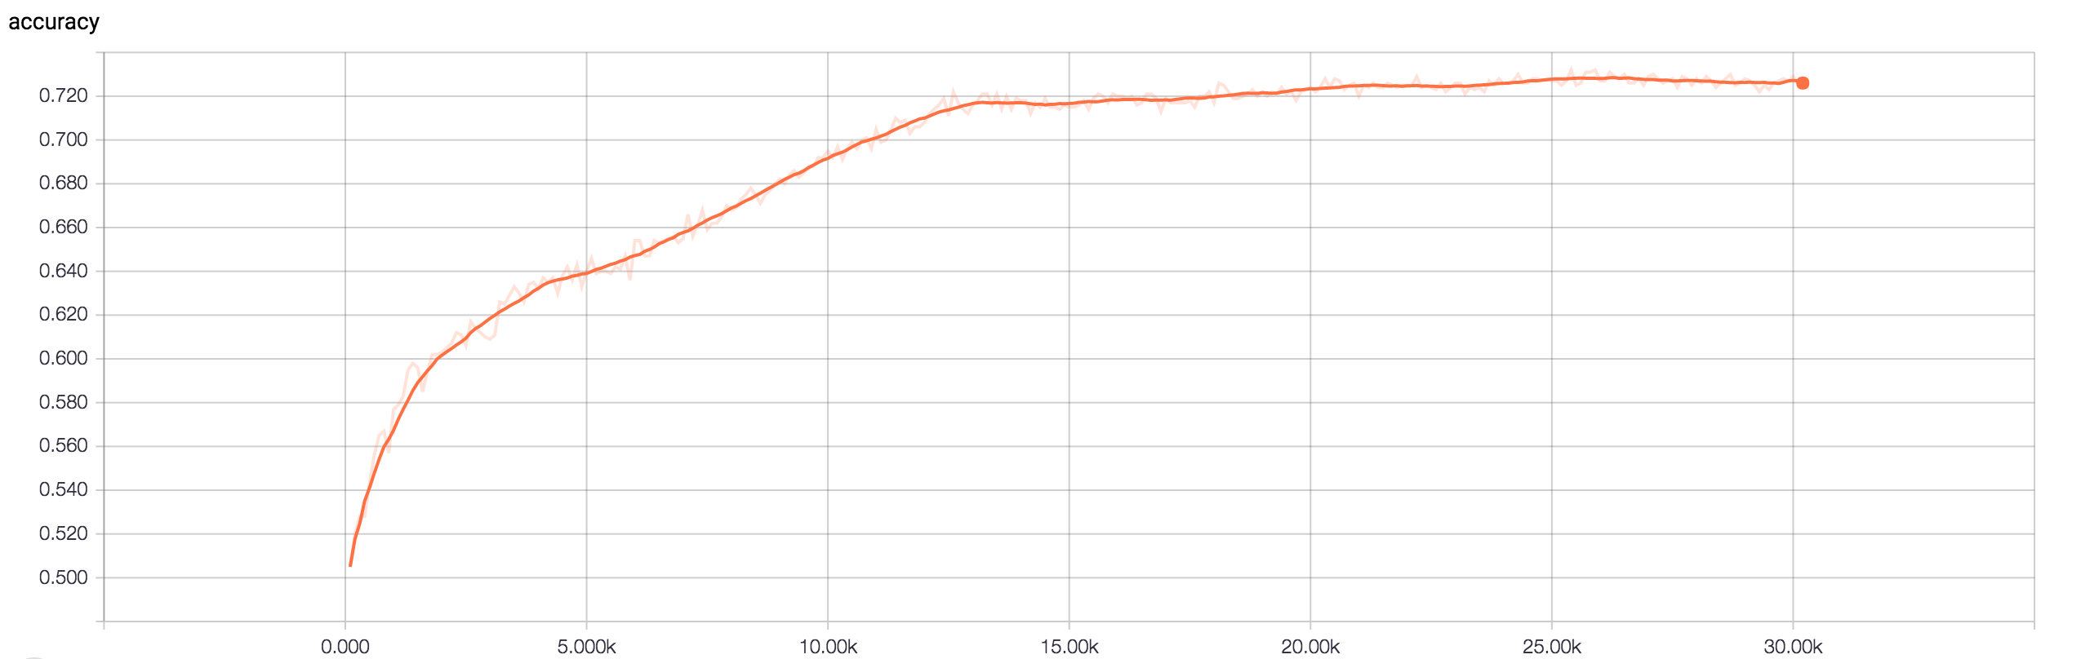

**Figure 1.** The development accuracy graph of a CNN run that was 200 epochs long.

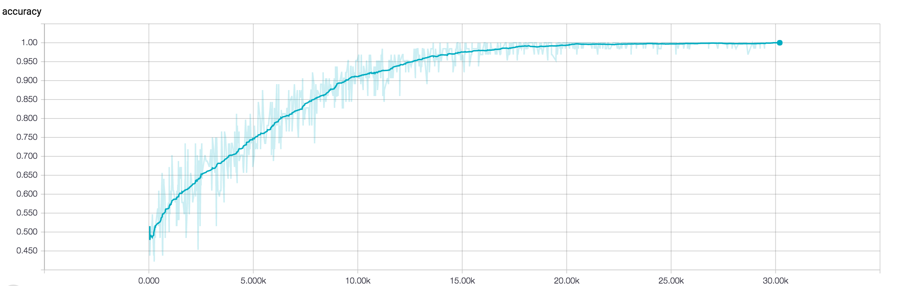

**Figure 2.** The training accuracy graph of a CNN run that was 200 epochs long.

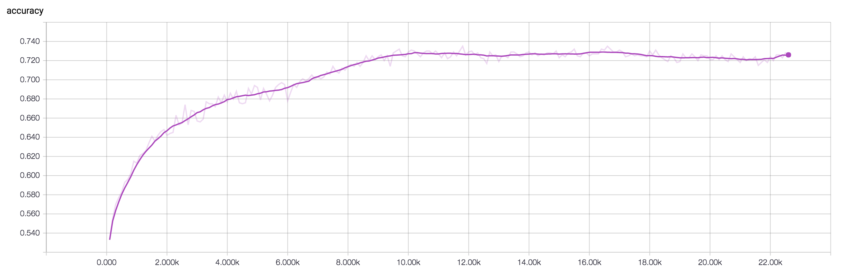

**Figure 3.** The development accuracy graph of a CNN run that was 150 epochs long.

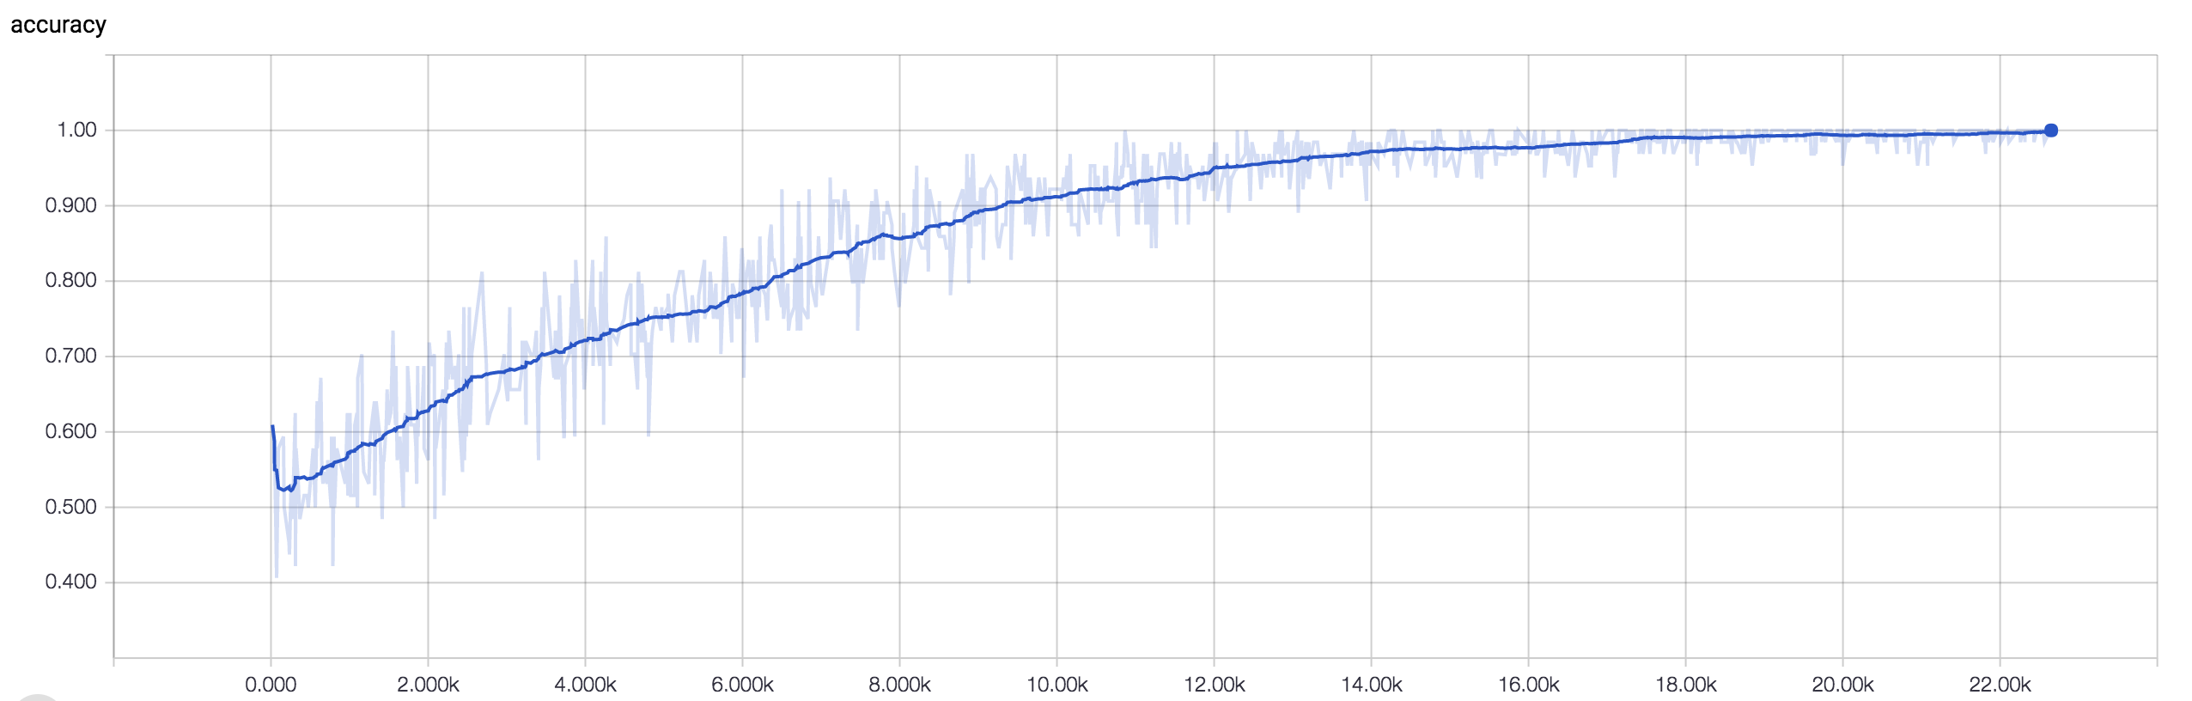

**Figure 4.** The training accuracy graph of a CNN run that was 150 epochs long.

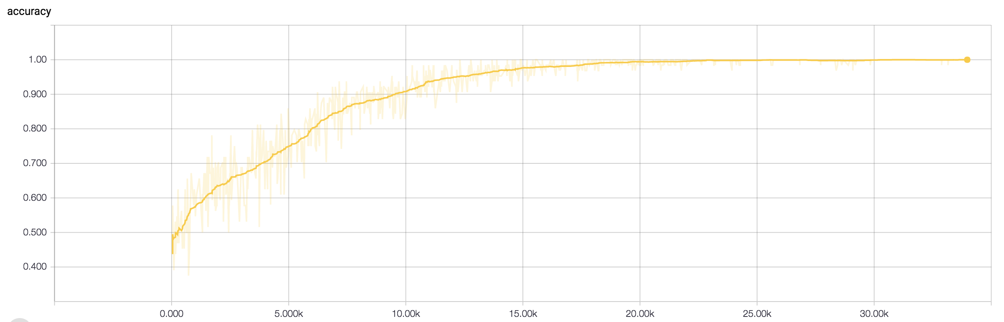

**Figure 5.** The training accuracy graph of a DCNN run that was 225 epochs long.

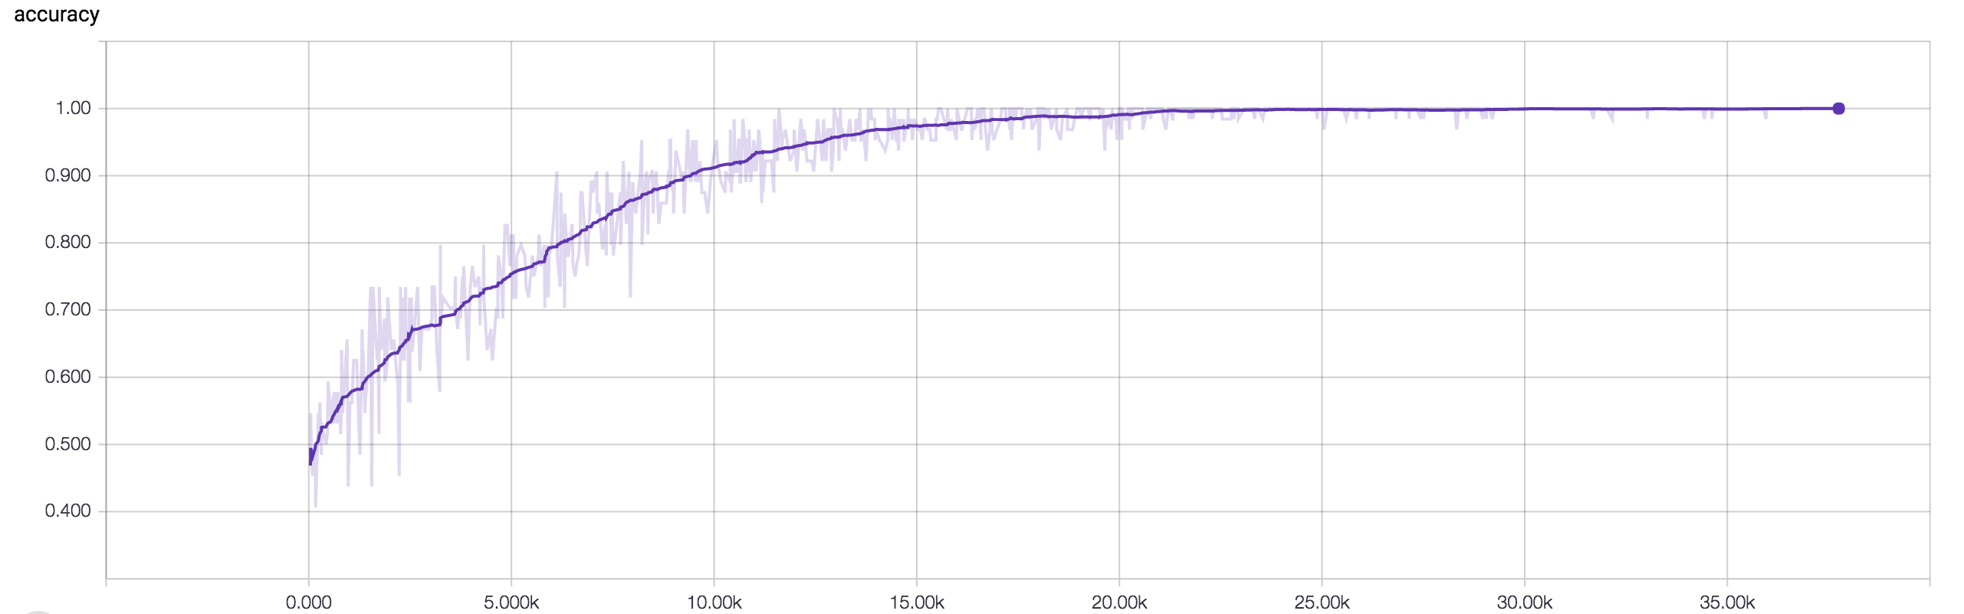

**Figure 6.** The training accuracy graph of a DCNN run that was 250 epochs long.

**Loss graphs**

All of the loss graphs were generated using TensorFlow and TensorBoard during the same runs as the accuracy graphs. The loss was calculated using softmax with logits. Again training graphs were self-validated while development graphs used an independent validation set.

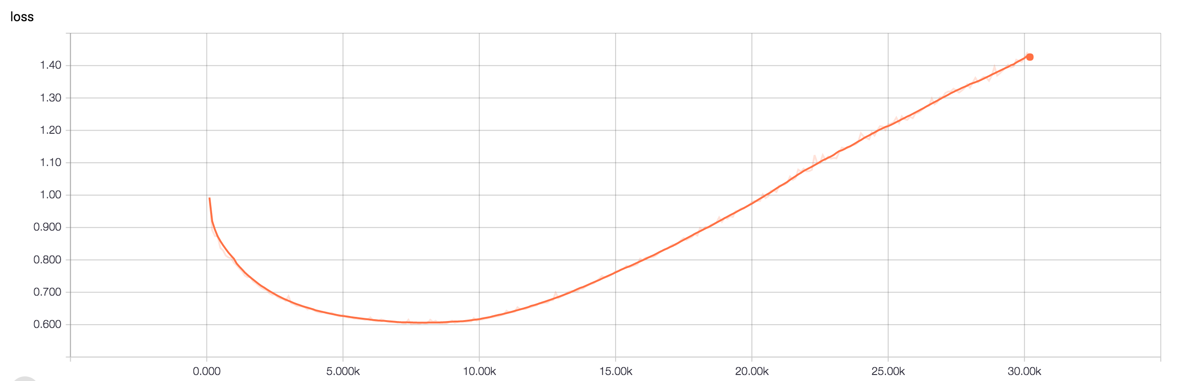

**Figure 7.** The development loss graph of a CNN run that was 200 epochs long.

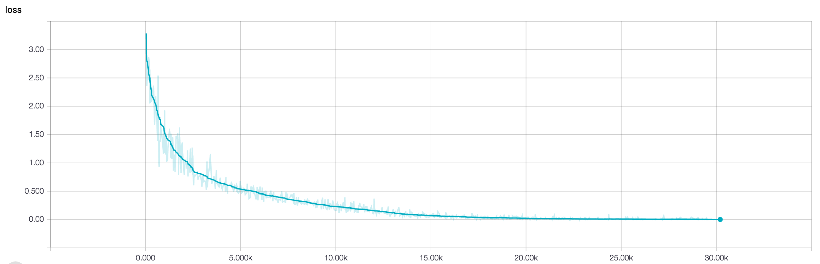

**Figure 8.** The training loss graph of a CNN run that was 200 epochs long.

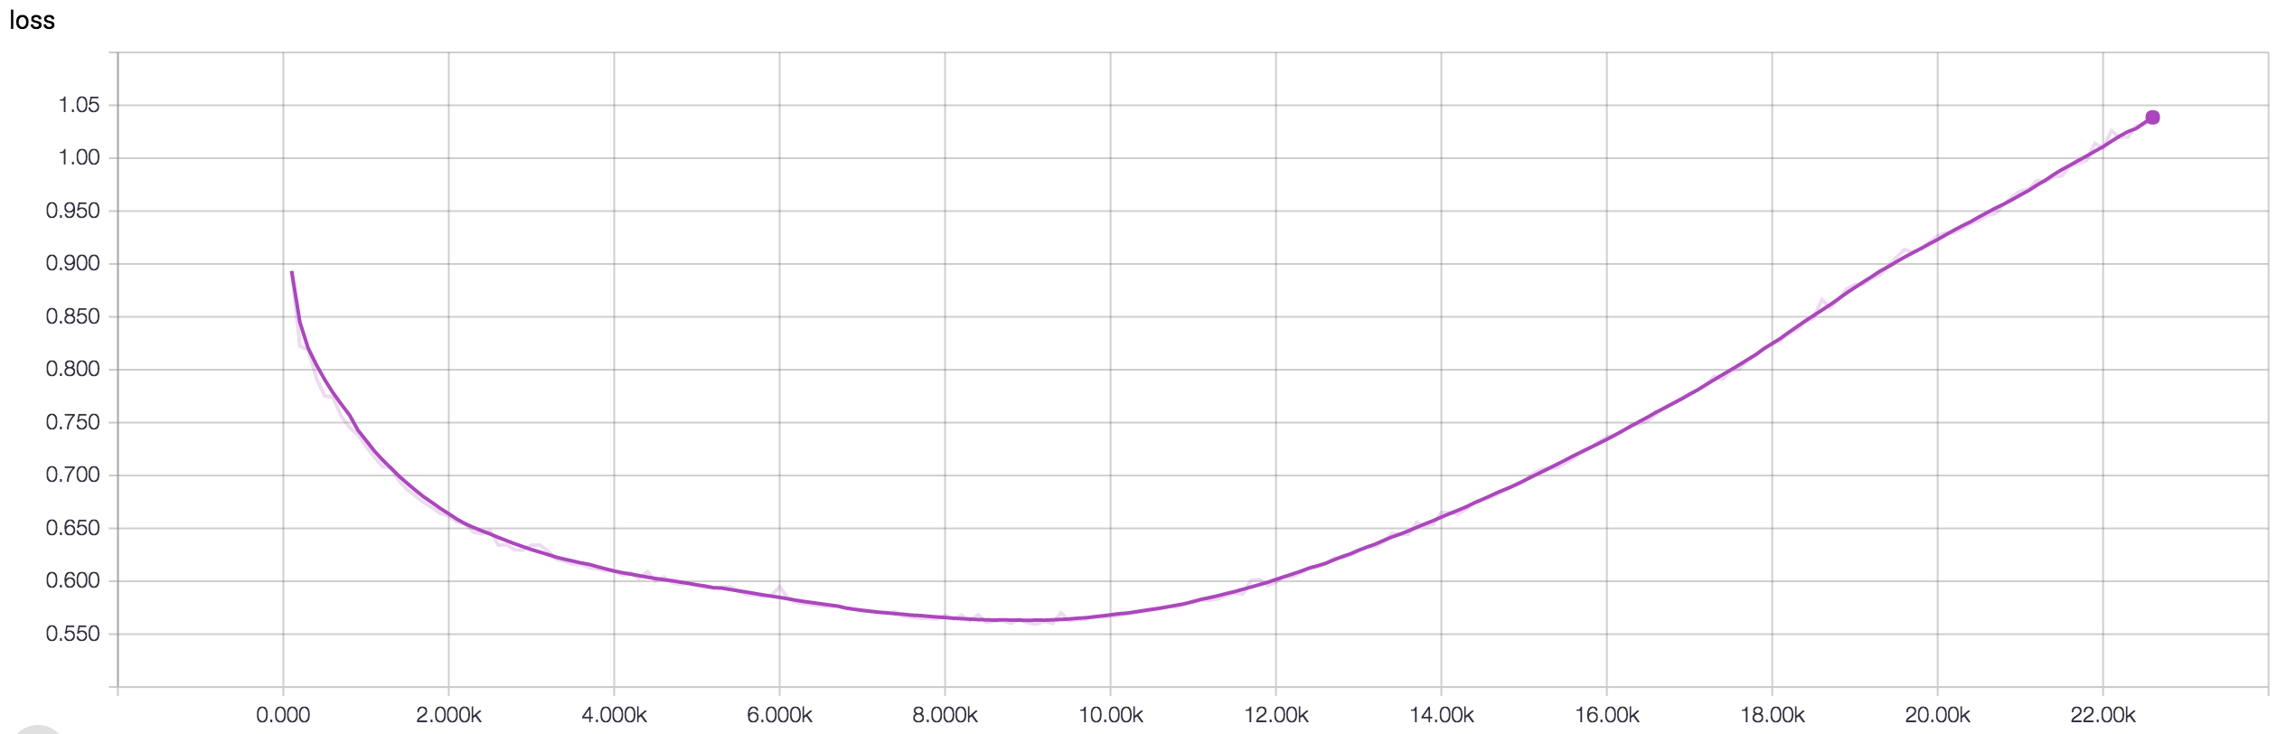

**Figure 9.** The development loss graph of a CNN run that was 150 epochs long.

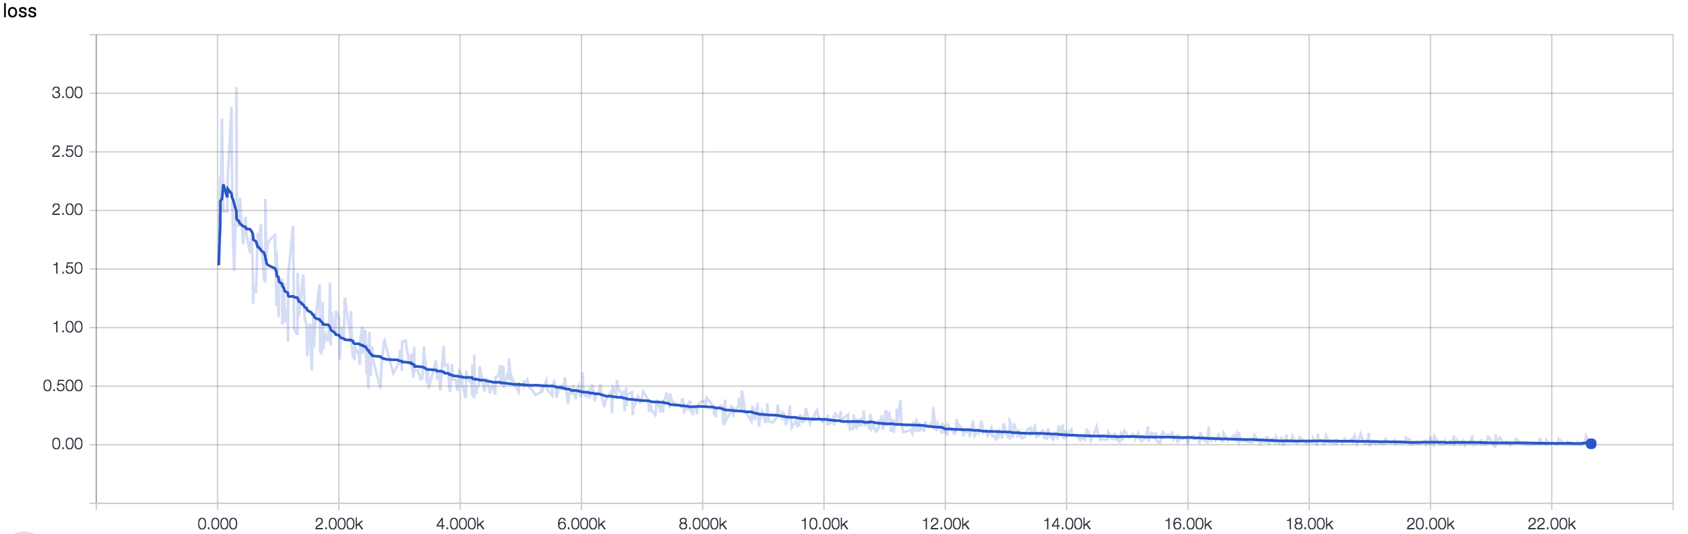

**Figure 10.** The training loss graph of a CNN run that was 150 epochs long.

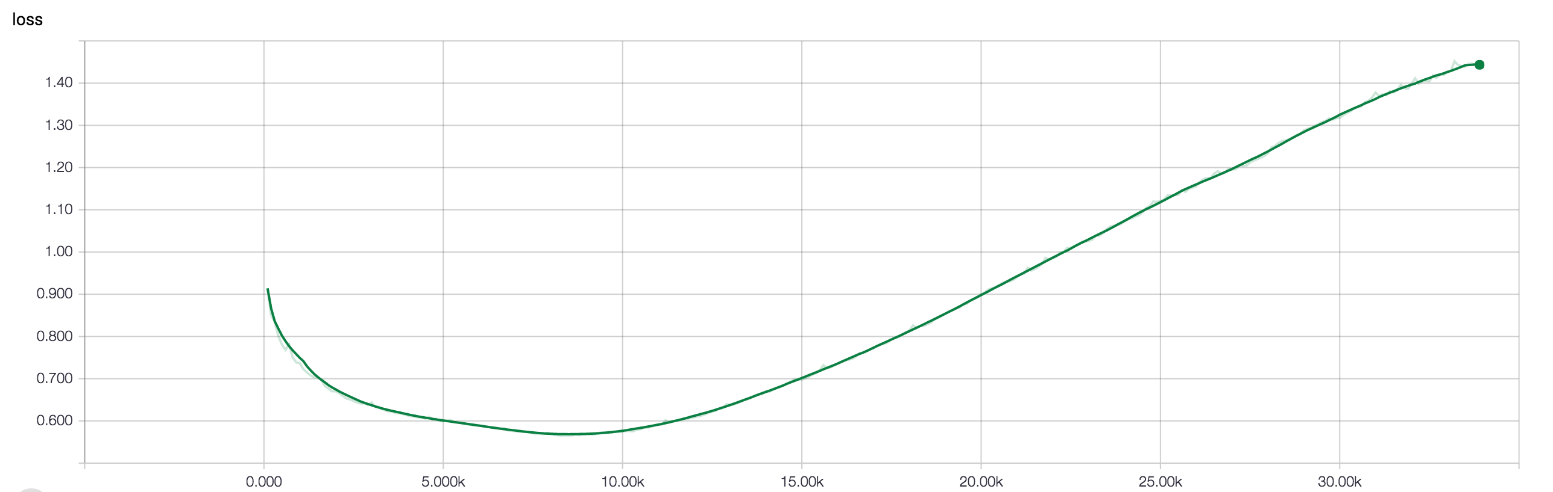

**Figure 11.** The development loss graph of a DCNN run that was 225 epochs long.

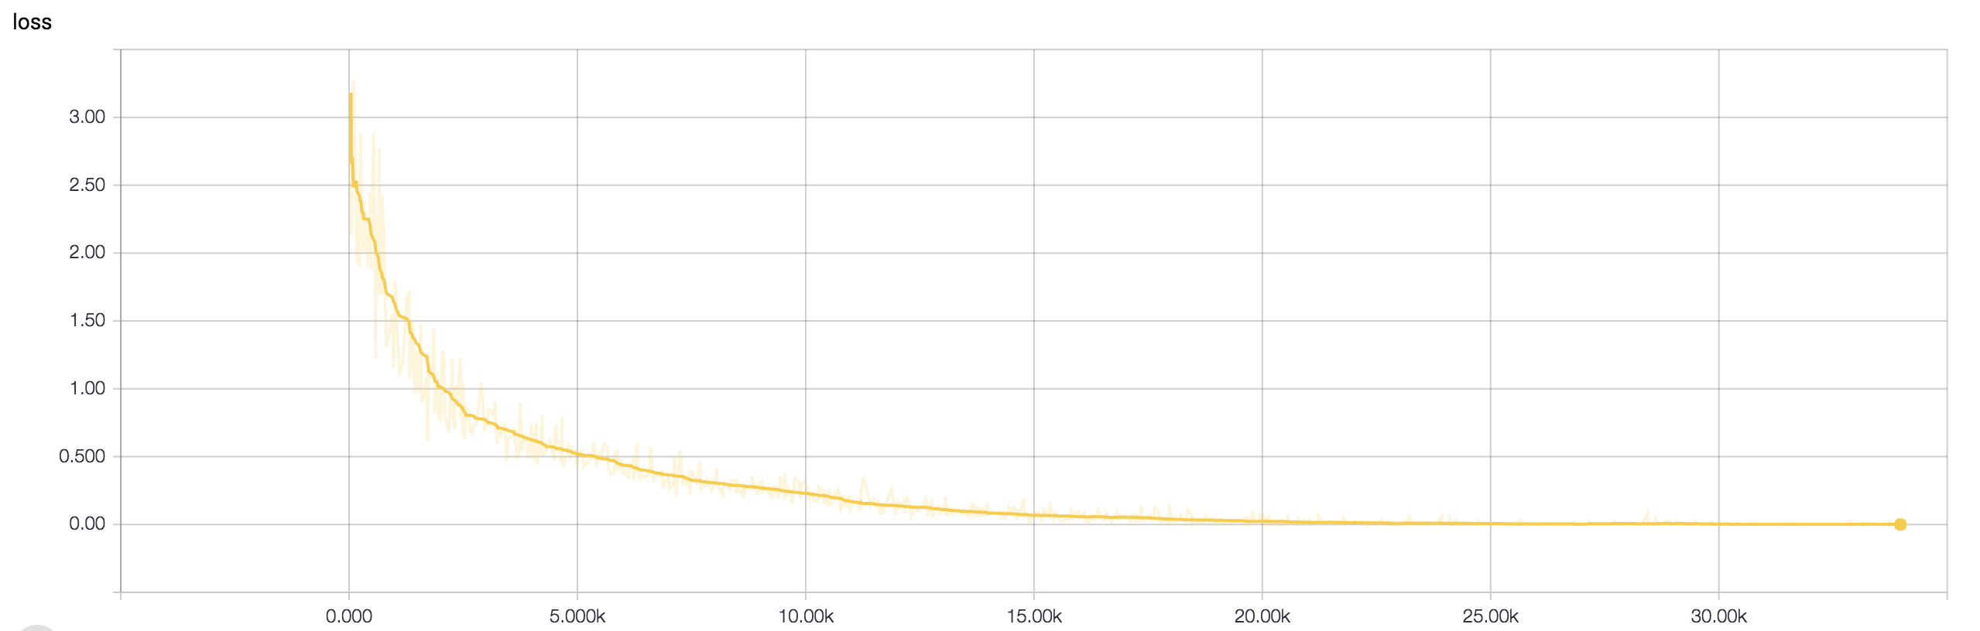

**Figure 11.** The training loss graph of a DCNN run that was 225 epochs long.

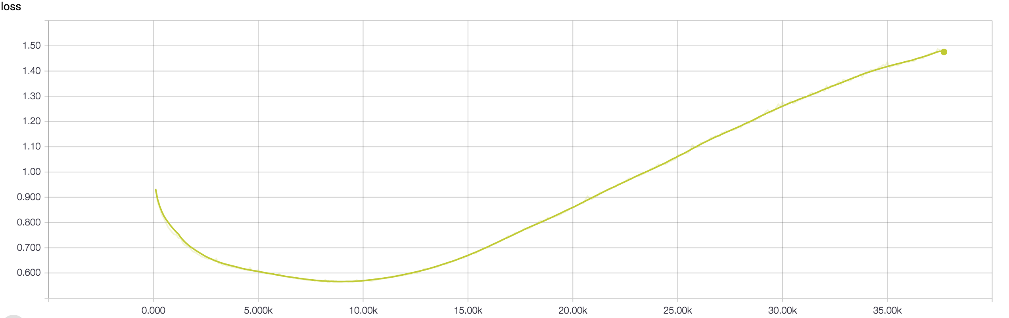

**Figure 12.** The development loss graph of a DCNN run that was 250 epochs long.

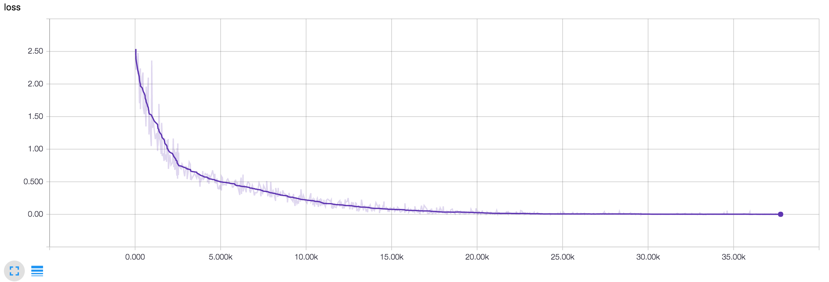

**Figure 13.** The training loss graph of a DCNN run that was 250 epochs long.

**SVM Data**

|  |  |  |  |
| --- | --- | --- | --- |
|  | Precision | Recall | F1-Score |
| Negative | 98% | 20% | 33% |
| Positive | 55% | 97% | 70% |
| Average/Total | 72% | 59% | 52% |

**Table 1.** The precision, recall, and F1-Score of the SVM. This SVM was trained using scikit learn’s SVC class.

**Other Data**

After deciding to use the SVM as my control, I decided to explore some of the other classifiers built into scikit learn. Because these classifiers were easy to train, I trained each one using basic parameters. For some of the models it seemed that the accuracy was 99-100%, but I believe that that was a pipelining issue with scikit-learn’s cross validation method that may have effected all of this data; in the future I would like to investigate further as some of the architectures (particularly the multi-layer perceptron) were lightweight but still quite effective.

|  |  |  |  |
| --- | --- | --- | --- |
|  | Precision | Recall | F1-Score |
| Negative | 100% | 99% | 100% |
| Positive | 99% | 100% | 100% |
| Average/Total | 100% | 100% | 100% |

**Table 2.** This is the precision, recall, and F1-Score scikit learn’s KNeighborsClassifier with k set to 3. The validation was clearly messed up on this one.

|  |  |  |  |
| --- | --- | --- | --- |
|  | Precision | Recall | F1-Score |
| Negative | 82% | 47% | 60% |
| Positive | 63% | 89% | 74% |
| Average/Total | 72% | 68% | 67% |

**Table 3.** This is the precision, recall, and F1-Score scikit learn’s SVC with a linear kernel and C set to 0.025.

|  |  |  |  |
| --- | --- | --- | --- |
|  | Precision | Recall | F1-Score |
| Negative | 100% | 100% | 100% |
| Positive | 100% | 100% | 100% |
| Average/Total | 100% | 100% | 100% |

**Table 4.** This is the precision, recall, and F1-Score scikit learn’s SVC with a RBF kernel and C set to 1. The validation was clearly messed up on this one.

|  |  |  |  |
| --- | --- | --- | --- |
|  | Precision | Recall | F1-Score |
| Negative | 58% | 68% | 62% |
| Positive | 61% | 50% | 55% |
| Average/Total | 59% | 59% | 59% |

**Table 5.** This is the precision, recall, and F1-Score scikit learn’s DecisionTree with max depth set to 5.

|  |  |  |  |
| --- | --- | --- | --- |
|  | Precision | Recall | F1-Score |
| Negative | 98% | 1% | 2% |
| Positive | 50% | 100% | 67% |
| Average/Total | 74% | 50% | 34% |

**Table 6.** This is the precision, recall, and F1-Score scikit learn’s RandomForest with max depth set to 5, estimators set to 10, and max features set to 1.

|  |  |  |  |
| --- | --- | --- | --- |
|  | Precision | Recall | F1-Score |
| Negative | 84% | 83% | 83% |
| Positive | 83% | 84% | 83% |
| Average/Total | 83% | 83% | 83% |

**Table 6.** This is the precision, recall, and F1-Score scikit learn’s MLP with alpha at 1. I have suspicions that there were pipelining issues that caused this data to look more promising than it actually is.

|  |  |  |  |
| --- | --- | --- | --- |
|  | Precision | Recall | F1-Score |
| Negative | 65% | 67% | 66% |
| Positive | 66% | 64% | 65% |
| Average/Total | 66% | 66% | 66% |

**Table 6.** This is the precision, recall, and F1-Score scikit learn’s AdaBoost.

**Final Data**

|  |  |
| --- | --- |
|  | Accuracy |
| DCNN | 85.00% |
| CNN | 71.92% |
| SVM | 72.00% |

**Table 2.** The final accuracies of the SVM, DCNN, and CNN when validated using an IMDB validation set that none of the architectures had been trained on.

Works Cited

Anguita, D., A. Boni, and S. Ridella. "A Digital Architecture for Support Vector Machines: Theory, Algorithm, and Fpga Implementation." *IEEE Transactions on Neural Networks* 14, no. 5 (2003): 993-1009. Accessed October 30, 2016. doi:10.1109/tnn.2003.816033.

Arpathy, K. "CS231n Convolutional Neural Networks for Visual Recognition." CS231n Convolutional Neural Networks for Visual Recognition. Accessed October 30, 2016. http://cs231n.github.io/convolutional-networks/.

Figure 3. Miller, Steven. Digital image. Http://stevenmiller888.github.io. August 10, 2015. Accessed October 30, 2016. http://stevenmiller888.github.io/mind-how-to-build-a-neural-network/.

Figure 4. Digital image. Http://mnemstudio.org/neural-networks-multilayer-perceptron-design.htm. Accessed October 30, 2016.

Haykin, Simon S. *Neural Networks: A Comprehensive Foundation*. New York: Macmillan, 1994.

Jaeger, Herbert. "A Tutorial on Training Recurrent Neural Networks, Covering BPPT, RTRL, EKF and the "echo State Network" Approach." *Fraunhofer Institute for Autonomous Intelligent Systems*, December 2013. Accessed October 30, 2016. http://minds.jacobs-university.de/sites/default/files/uploads/papers/ESNTutorialRev.pdf.

Kalchbrenner, Nal, Edward Grefenstette, and Phil Blunsom. "A Convolutional Neural Network for Modelling Sentences." *Proceedings of the 52nd Annual Meeting of the Association for Computational Linguistics (Volume 1: Long Papers)*, 2014. doi:10.3115/v1/p14-1062.

Powers, David M.W. "Evaluation: From Precision, Recall and F-Factor to ROC, Informedness, Markedness & Correlation." *School of Informatics and Engineering Technical Report* 7, no. 1 (December 2007). Accessed October 30, 2016.

Rosenblatt, F. "The Perceptron: A Probabilistic Model for Information Storage and Organization in the Brain." *Psychological Review* 65, no. 6 (1958): 386-408. doi:10.1037/h0042519.

Samuel, A. L. "Some Studies in Machine Learning Using the Game of Checkers." *IBM Journal of Research and Development* 3, no. 3 (1959): 210-29. doi:10.1147/rd.33.0210.

Silver, David, Aja Huang, Chris J. Maddison, Arthur Guez, Laurent Sifre, George Van Den Driessche, Julian Schrittwieser, Ioannis Antonoglou, Veda Panneershelvam, Marc Lanctot, Sander Dieleman, Dominik Grewe, John Nham, Nal Kalchbrenner, Ilya Sutskever, Timothy Lillicrap, Madeleine Leach, Koray Kavukcuoglu, Thore Graepel, and Demis Hassabis. "Mastering the Game of Go with Deep Neural Networks and Tree Search." *Nature* 529, no. 7587 (2016): 484-89. doi:10.1038/nature16961.

"TensorFlow Is an Open Source Software Library for Machine Intelligence." TensorFlow. Accessed October 30, 2016. https://www.tensorflow.org/.

"What I Learned from Competing against a ConvNet on ImageNet." What I Learned from Competing against a ConvNet on ImageNet. September 2, 2014. Accessed October 30, 2016. http://karpathy.github.io/2014/09/02/what-i-learned-from-competing-against-a-convnet-on-imagenet/.

I learned machine learning and TensorFlow primarily by reading and watching videos online. Throughout this process I made many smaller programs along the way. All of these programs can be found at <https://github.com/dsiegler19/learning_machine_learning>.

As well, along the way in my code I commented about some of the things I learned or found.

**Notes runs of classifiers for sentiment analysis:**

Good parameters for the classifiers  
All data trained using parameter_tuning.py.  
  
NuSVC classifier data (with movie_reviews) [3/7/16]:  
  
(n = 30)  
+------+----------+  
| Nu | Accuracy |  
+------+----------+  
| 0.4 | 71.0 |  
| 0.5 | 73.8 |  
| 0.6 | 72.3 |  
| 0.7 | 72.9 |  
| 0.75 | 72.8 |  
| 0.8 | 73.0 | <==  
+------+----------+  
  
Best nu value is 0.8  
  
Degree is inconsequential, so degree will be 3. As well, changing decision_function_shape to "ovr" is recommended so  
it will be done.  
  
RandomForestClassifier (with movie_reviews) [4/7/16]:  
  
(n = 30)  
+---------------------------+----------+  
| n_estimators (# of trees) | Accuracy |  
+---------------------------+----------+  
| 6 | 64.0 |  
| 8 | 64.1 |  
| 10 | 65.9 |  
| 12 | 66.8 |  
| 14 | 67.8 |  
| 16 | 69.1 |  
| 20 | 71.6 |  
| 25 | 75.1 | <==  
+---------------------------+----------+  
  
n_estimators = 25 is the point at which the growth in accuracy slows down significantly but the running time increases  
significantly, so n_estimator = 25 is the best value.  
  
(n = 30)  
+------------------+----------+  
| min_samples_leaf | Accuracy |  
+------------------+----------+  
| 1 | 74.4 |  
| 2 | 75.0 |  
| 3 | 75.1 |  
| 4 | 74.9 |  
| 5 | 74.5 |  
| 6 | 76.6 | <==  
| 7 | 75.9 |  
| 8 | 74.4 |  
| 9 | 75.7 |  
| 10 | 73.9 |  
| 11 | 75.2 |  
| 12 | 74.5 |  
| 13 | 74.0 |  
| 14 | 74.3 |  
| 15 | 73.5 |  
| 16 | 73.7 |  
| 17 | 72.8 |  
| 18 | 74.3 |  
| 19 | 74.1 |  
| 20 | 71.1 |  
| 25 | 69.9 |  
| 30 | 67.7 |  
| 35 | 69.2 |  
| 40 | 67.7 |  
| 45 | 68.0 |  
| 50 | 65.7 |  
| 55 | 63.1 |  
| 60 | 64.6 |  
| 65 | 62.5 |  
| 70 | 62.8 |  
| 75 | 62.2 |  
| 80 | 64.3 |  
| 85 | 60.5 |  
| 90 | 61.8 |  
| 95 | 59.4 |  
| 100 | 57.9 |  
+------------------+----------+  
  
The best min_samples_leaf is 6.  
A graph of this data can be found at min_samples_leaf_to_accuracy.png.  
  
The average accuracy of the OpinionLexiconClassifier in opinion_lexicon_classifier.py (n = 100) is 62.2.  
  
The average accuracy of the LinearSVC algorithm (n = 60) is 78.3.  
  
(n = 30)  
+-----+----------+  
| C | Accuracy |  
+-----+----------+  
| 0.2 | 76.9 |  
| 0.4 | 77.8 |  
| 0.6 | 78.9 |  
| 0.8 | 78.4 |  
| 1.0 | 78.3 | <==  
| 1.2 | 76.8 |  
| 1.4 | 78.6 |  
| 1.6 | 77.1 |  
| 1.8 | 77.1 |  
| 2.0 | 78.0 |  
| 2.2 | 76.9 |  
| 2.4 | 77.6 |  
| 2.6 | 77.7 |  
| 2.8 | 77.6 |  
| 3.0 | 78.1 |  
| 3.2 | 78.6 |  
| 3.4 | 77.8 |  
| 3.6 | 78.5 |  
| 3.8 | 75.7 |  
| 4.0 | 76.3 |  
| 4.2 | 76.8 |  
| 4.4 | 77.0 |  
| 4.6 | 77.3 |  
| 4.8 | 77.7 |  
| 5.0 | 78.4 |  
| 5.2 | 78.3 |  
| 5.4 | 77.4 |  
| 5.6 | 77.6 |  
| 5.8 | 78.0 |  
| 6.0 | 77.9 |  
| 6.2 | 78.6 |  
| 6.4 | 78.9 |  
| 6.6 | 77.8 |  
| 6.8 | 76.9 |  
| 7.0 | 77.7 |  
| 7.2 | 79.2 |  
| 7.4 | 77.8 |  
| 7.6 | 78.0 |  
| 7.8 | 78.0 |  
| 8.0 | 76.9 |  
| 8.2 | 77.5 |  
| 8.4 | 77.6 |  
| 8.6 | 77.2 |  
| 8.8 | 78.2 |  
| 9.0 | 79.4 |  
| 9.2 | 77.2 |  
| 9.4 | 77.3 |  
| 9.6 | 77.7 |  
| 9.8 | 77.9 |  
+-----+----------+  
  
Although C values at 9.0 and 7.2 do provide accuracy above 79.0%, this is hardly statistically significant. It seems  
that by C = 0.6 the C value has hit a critical mass and after this point raising the C value provides no increase in  
accuracy. For this reason, C = 1.0.  
  
The default accuracy of the scikit learn Support Vector Classifier (SVC) is ~50%. However, this can be greatly increased  
by upping the C value.  
  
(n = 30)  
+-----+----------+-----------------------------+  
| C | Accuracy | Average Training Time (sec) |  
+-----+----------+-----------------------------+  
| 5 | 75.3 | 23.2 |  
| 10 | 78.3 | 22.6 |  
| 15 | 80.4 | 22.3 | <==  
| 20 | 79.1 | 22.1 |  
| 25 | 80.0 | 22.0 |  
| 30 | 80.6 | 21.9 |  
| 35 | 79.7 | 21.8 |  
| 40 | 80.2 | 21.7 |  
| 45 | 80.7 | 21.8 |  
| 50 | 79.9 | 21.7 |  
| 55 | 80.7 | 21.5 |  
| 60 | 80.7 | 21.6 |  
| 65 | 79.5 | 21.5 |  
| 70 | 80.2 | 21.4 |  
| 75 | 80.1 | 21.4 |  
| 80 | 81.2 | 21.4 |  
| 85 | 81.0 | 21.4 |  
| 90 | 80.6 | 21.4 |  
| 95 | 80.0 | 21.3 |  
| 100 | 81.2 | 21.3 |  
+-----+----------+-----------------------------+  
  
C value of 15 seems to provide sufficient accuracy. As well, changing decision_function_shape to "ovr" is recommended so  
it will be done.  
  
(n = 30)  
+--------+----------+-----------------------------+  
| Degree | Accuracy | Average Training Time (sec) |  
+--------+----------+-----------------------------+  
| 1 | 47.8 | 22.9 |  
| 2 | 50.3 | 22.9 |  
| 3 | 47.9 | 22.9 |  
| 4 | 48.3 | 22.8 |  
| 5 | 46.4 | 22.9 |  
| 6 | 51.8 | 22.9 |  
| 7 | 50.2 | 22.9 |  
| 8 | 46.3 | 22.8 |  
| 9 | 46.3 | 22.9 |  
| 10 | 46.5 | 22.9 |  
+--------+----------+-----------------------------+  
  
The degree remains inconsequential, so it will be kept at the default of 3.  
  
The scikit learn Stochastic Gradient Descent Classifier (SGDC) provides a default accuracy of 77.4%.  
  
(n = 30)  
+---------------------------+----------+---------------------+  
| Loss | Accuracy | Training Time (sec) |  
+---------------------------+----------+---------------------+  
| hinge | 78.8 | 20.2 | <==  
| log | 77.1 | 18.1 |  
| modifier_huber | 78.3 | 18.0 |  
| squared_hinge | 77.0 | 18.0 |  
| perceptron | 76.8 | 18.0 |  
| squared_loss | 48.3 | 18.0 |  
| huber | 53.7 | 18.0 |  
| epsilon_insensitive | 50.4 | 18.0 |  
| squared_epsilon_intensive | 49.7 | 18.1 |  
+---------------------------+----------+---------------------+  
  
The default of hinge provides the best results, so it will remain.  
  
The scikit learn Logistic Regression algorithm provides a default accuracy of 77.9%.  
  
(n = 30)  
+----+----------+---------------------+  
| C | Accuracy | Training Time (sec) |  
+----+----------+---------------------+  
| 2 | 79.4 | 18.9 | <==  
| 4 | 79.6 | 22.5 |  
| 6 | 80.2 | 21.9 |  
| 8 | 79.5 | 20.3 |  
| 10 | 80.0 | 18.2 |  
| 12 | 80.0 | 18.6 |  
| 14 | 79.4 | 20.3 |  
| 16 | 80.1 | 17.6 |  
| 18 | 79.2 | 17.6 |  
| 20 | 80.5 | 17.5 |  
| 22 | 78.5 | 17.5 |  
| 24 | 80.0 | 17.6 |  
| 26 | 79.6 | 17.5 |  
| 28 | 79.9 | 17.6 |  
| 30 | 78.7 | 17.5 |  
| 32 | 79.2 | 17.5 |  
| 34 | 79.4 | 17.5 |  
| 36 | 80.1 | 17.4 |  
| 38 | 78.4 | 17.6 |  
| 40 | 80.0 | 17.5 |  
| 42 | 79.7 | 17.6 |  
| 44 | 78.7 | 17.6 |  
| 46 | 79.6 | 17.4 |  
| 48 | 79.4 | 17.4 |  
+----+----------+---------------------+  
  
Since C seems inconsequential, it will be set to 2.  
  
The Bernoulli Naïve Bayes provides a default accuracy of 77.5% with training time of 22.1 seconds (n = 60). There are no  
parameters to tune.  
  
The Multinomial Naïve Bayes provides a default accuracy of 79.0% with training time of 21.0 seconds (n = 60). There are no  
parameters to tune.  
  
The AdaBoostClassifier provides a default accuracy of 73.6% with a training time of 18.8 seconds (n = 60).  
  
(n = 30)  
+--------------+----------+---------------------+  
| n_estimators | Accuracy | Training Time (sec) |  
+--------------+----------+---------------------+  
| 5 | 62.6 | 18.2 |  
| 10 | 67.5 | 18.3 |  
| 15 | 67.5 | 18.4 |  
| 20 | 70.2 | 18.3 |  
| 25 | 69.2 | 18.3 |  
| 30 | 71.5 | 18.4 |  
| 35 | 73.2 | 18.6 |  
| 40 | 72.9 | 18.5 |  
| 45 | 73.4 | 18.6 |  
| 50 | 74.9 | 18.8 |  
| 55 | 74.9 | 19.0 |  
| 60 | 75.7 | 19.1 | <==  
| 65 | 75.6 | 19.3 |  
| 70 | 74.1 | 19.1 |  
| 75 | 74.3 | 19.2 |  
| 80 | 76.1 | 19.3 |  
| 85 | 75.9 | 19.6 |  
| 90 | 75.9 | 19.4 |  
| 95 | 75.6 | 19.8 |  
| 100 | 76.3 | 19.6 |  
+--------------+----------+---------------------+  
  
The default of 50 provides adequate accuracy, so it shall remain.  
  
DON'T USE:  
NLTK MAXENTCLASSIFIER  
NLTK DECISIONTREECLASSIFIER  
NLTK RANDOMFORESTCLASSIFIER  
SCIKIT LEARN GAUSSIANNB  
  
------------------------------------------------------------------------------------------------------------------------  
Feature Extraction  
All data gathered from parameter_tuning.py  
  
Using stop word filtering yielded the following results for the NuSVC classifier with nu = 0.75 (n = 10):  
66.97% Accuracy (with an old data set)  
  
Stemming yielded a loss of ~5-10% accuracy (on average)  
  
(n = 30)  
+----------------------------+----------+  
| # of Top Features Included | Accuracy |  
+----------------------------+----------+  
| 2000 | 67.9 |  
| 3000 | 71.5 |  
| 4000 | 70.6 |  
| 5000 | 75.2 |  
| 6000 | 75.4 |  
| 7000 | 76.9 |  
| 8000 | 77.2 |  
| 9000 | 79.3 | <==  
| 10000 | 80.1 |  
| 11000 | 81.1 |  
| 12000 | 81.1 |  
| 13000 | 80.1 |  
| 14000 | 81.7 |  
| 20000 | 82.3 |  
+----------------------------+----------+  
  
9000 seems to be the point at which the increase in accuracy slows down the most. For now, 9000 will be used.  
  
Using only adverbs (as apposed to adverbs and verbs) in featureset provides an increase in accuracy.  
  
Surprisingly, bigrams provided no advantage in accuracy and in general only made training times slower.  
  
+---------------+-----------------+----------+  
| Top all_words | Top all_bigrams | Accuracy |  
+---------------+-----------------+----------+  
| 0 | 9000 | 50.1 |  
| 1000 | 8000 | 64.9 |  
| 2000 | 7000 | 68.4 |  
| 3000 | 6000 | 70.6 |  
| 4000 | 5000 | 71.0 |  
| 5000 | 4000 | 71.9 |  
| 6000 | 3000 | 73.3 |  
| 7000 | 2000 | 74.5 |  
| 8000 | 1000 | 76.1 |  
| 9000 | 0 | 76.1 | <==  
| 9000 | 500 | 74.8 |  
| 9000 | 1000 | 75.4 |  
| 9000 | 1500 | 74.9 |  
| 9000 | 2000 | 75.8 |  
| 9000 | 2500 | 74.3 |  
| 9000 | 3000 | 75.9 |  
| 9000 | 3500 | 74.8 |  
| 9000 | 4000 | 75.2 |  
| 9000 | 4500 | 74.9 |  
| 9000 | 5000 | 74.9 |  
| 9000 | 5500 | 75.4 |  
| 9000 | 6000 | 75.5 |  
| 9000 | 6500 | 75.1 |  
| 9000 | 7000 | 75.8 |  
| 9000 | 7500 | 75.6 |  
| 9000 | 8000 | 74.3 |  
| 9000 | 8500 | 74.1 |  
| 9000 | 9000 | 75.4 |  
+---------------+-----------------+----------+  
  
The original configuration of the top 9000 of all_words and no bigrams yields the best results. Although trigrams and  
higher ngrams (with n as high as 5) are recommended, it seems that even bigrams simply make way to much noise, so other  
ngrams won't be considered or tested.  
  
------------------------------------------------------------------------------------------------------------------------  
  
Old data:  
  
NuSVC classifier data (with short_reviews) [2/7/16]:  
  
(n = 10):  
+------+----------+  
| Nu | Accuracy |  
+------+----------+  
| 0.4 | 60.97 |  
| 0.45 | 63.55 |  
| 0.5 | 63.65 |  
| 0.55 | 64.76 |  
| 0.6 | 66.00 |  
| 0.65 | 65.36 |  
| 0.7 | 67.12 |  
| 0.75 | 67.23 | <==  
| 0.8 | 66.74 |  
| 0.85 | 67.17 |  
+------+----------+  
  
Best nu value is 0.75.  
  
(n = 10)  
+--------+----------+  
| Degree | Accuracy |  
+--------+----------+  
| 2 | 67.02 |  
| 3 | 66.40 |  
| 4 | 66.94 |  
+--------+----------+  
  
Degree is inconsequential, so degree is 3.

**Notes on general topics when I was learning about NLP using NLTK (some of the formatting is messed up):**

Tokenizing -  
 Word tokenizer - separates by word  
 Sentence tokenizer - separates by sentence  
There are many ways to tokenize using nltk. There are 3 included in Tutorials/tokenizing.py (nltk's naitive tokenizer,  
trained PunktSentenceTokenizer, and pretrained PunktSentenceTokenizer):  
  
==========================================================  
  
Lexicon - The words and their meanings (dictionary, financial speak). On this computer, lexicon (and corpora) are found  
in /Users/dsiegler19/nltk_data/corpora.  
Corpora - A body of text (i.e. medical journals, presidential speeches, anything in the english language). On this  
computer, corpora (and lexicon) are found in /Users/dsiegler19/nltk_data/corpora.  
  
Some examples are found in Tutorials/lexicon_and_corpora.py  
  
===========================================================  
  
Stop words - Commonly used words like and, by, then, at, etc. that provide no real meaning to the computer, so  
they are often ignored completely. Code to do this is in Tutorials/stop_words.py.  
  
===========================================================  
  
Stemming - A process of "normalizing" words. It removes things like tense, person, number, etc.  
  
 I was taking a ride in the car  
 I was riding in the car  
  
These sentences mean the same thing, so stemming would turn both of these verbs into simply ride.  
  
 Eat  
 Eating  
 Was eating  
 About to eat  
 Will eat  
 Eater  
 Eaten  
  
These would all simply become eat. Code to do this is in Tutorials/stemming.py.  
  
===========================================================  
  
Part of speech tagging - Labeling the part of speech for every word.  
  
Part of speech tag list:  
|-------------------------------------------------------------------------------|  
|Abbreviation | Meaning/Explanation | Example |  
|-------------|----------------------------------------|------------------------|  
| CC | coordinating conjunction | and |  
| CD | cardinal digit | 7 |  
| DT | determiner | an |  
| EX | existential | there is/there exists |  
| FW | foreign word | bonjour |  
| IN | preposition/subordinating conjunction | under/because |  
| JJ | adjective | big |  
| JJR | adjective, comparative | bigger |  
| JJS | adjective, superlative | biggest |  
| LS | list marker | 1) |  
| MD | modal | will, could |  
| NN | noun, singular | desk |  
| NNS | noun plural | desks |  
| NNP | proper noun, singular | Smith |  
| NNPS | proper noun, plural | Americans |  
| PDT | predeterminer | all |  
| POS | possessive ending | parent's |  
| PRP | personal pronoun | I, he, she |  
| PRP$ | possessive pronoun | my, his, hers |  
| RB | adverb | silently |  
| RBR | adverb, comparative | silenter |  
| RBS | adverb, superlative | silentist |  
| RP | particle (doesn't inflect) | give up (only up) |  
| TO | the word to in any use | to |  
| UH | interjection | errrrrrrrm |  
| VB | verb, base form | take |  
| VBD | verb, past tense | took |  
| VBG | verb, gerund/present participle | taking |  
| VBN | verb, past participle | taken |  
| VBP | verb, sing. present, non-3d | take |  
| VBZ | verb, 3rd person sing. present | takes |  
| WDT | wh-determiner | which |  
| WP | wh-pronoun | who, what |  
| WP | possessive wh-pronoun | whose |  
| WRB | wh-abverb | where, when |  
|-------------------------------------------------------------------------------|  
  
Code to do this is in Tutorials/POS_tagging.py.  
  
===========================================================

Chunking - Given that some text has been tokenized by word and sentence and has been tagged by part of speech, chunking  
finds the named entities (nouns), words that modify each of these named entities, and what each one is referring to.  
Chunking splits each sentence into noun phrases. Chunked words must be next to each other.  
  
Chunking is mainly done using regular expressions. Here is a tutorial on regular expressions:  
https://pythonprogramming.net/regular-expressions-regex-tutorial-python-3/  
  
By convention the chunk is included in a raw triple quote string (see example code):  
  
 regex expression  
r"""ChunkName: {<POSIdentifier>}"""  
  
Code to do this (with a regular expression that can be improved upon) is in Tutorials/chunking.py.  
  
===========================================================  
  
Chinking - Removing something from a chunk. One can say to chunk everything and then chink (remove) a few things from  
the chunks. Chinking is also done via regular expressions and is in the same string as the chunk (see example code).  
Code to do this (with regular expressions that can be improved upon) is in Tutorials/chinking.py.  
  
===========================================================  
  
Name Entity Recognition - A way of chunking to find most proper nouns. The nltk.ne_chunk() method finds things such as  
names, places, organizations, dates, money, and other named entities. When binary argument of nltk.ne_chunk() is true,  
named entities will all be categorized as NE. This means a phrase like "White House" will be categorized as one chunk  
since they are both simply NEs. When binary is false (default), it will provide more specific categories of named  
entities such as PERSON or GPE. As well, when binary is false it will separate a phrase such as "White House" into  
White (FACILITY) and House (ORGANIZATION).  
  
Named entity types and examples:  
|----------------------------------------------------------|  
| Name | Example |  
|----------------------------------------------------------|  
| ORGANIZATION | Georgia-Pacific Corp., WHO |  
| PERSON | Eddy Bonte, President Obama |  
| LOCATION | Murray River, Mount Everest |  
| DATE | June, 2008-06-29 |  
| TIME | two fifty a m, 1:30 p.m. |  
| MONEY | 175 million Canadian Dollars, GBP 10.40 |  
| PERCENT | twenty pct, 18.75 % |  
| FACILITY | Washington Monument, Stonehenge |  
| GPE | South East Asia, Midlothian |  
|----------------------------------------------------------|  
  
Code to do this can be found in Tutorials/NE_recognition.py.  
  
===========================================================  
  
Lemmatizing - A similar operation to stemming, but the end result is an actual word. That word may be the root of the  
original word or it may be a synonym. Lemmatizing is often better and more effective then stemming. The lemmatizer  
assumes that all words it is given are nouns, so one must specify if the word is not a noun for the lemmatizer to  
lemmatize it correctly.  
  
Code to do this can be found in Tutorials/lemmatizing.py  
  
===========================================================  
  
WordNet - WordNet is a tool for looking up synonyms, antonyms, definitions, context of words, and many other useful  
tools. This tool also includes a lexicon of the English language, a synonym and antonym dictionary, and a word context  
dictionary. Some ways to use WordNet are:  
  
- Find all of the synonyms and antonyms of words  
- Find the definitions of a word  
- Find example uses of a word  
- Test to see how similar 2 words are  
  
Code to do all of this can be found in Tutorials/wordnet.py.  
  
===========================================================  
  
Text Classification using Sentimental Analysis - A way of classifying text as having a positive, negative, or neutral  
opinion/connotation of what they are talking about.  
  
Code to do this can be found in TextClassifier/text_classifier.py  
  
===========================================================  
  
Pickle - A module that can be used to save Python objects. In this case it is used to save the training data in  
TextClassifier/text_classifier.py.  
  
===========================================================  
  
Sicit-Learn - A machine learning module used in conjunction with nltk.

Many of my notes can be found in the code at <https://github.com/dsiegler19/learning_machine_learning>.